**An Internship Report**

On

**Smart Bridge – Automatic Height adjustment During Natural**

**Calamities**

Submitted in partial fulfilment of the requirements for the award of the degree of

**BACHELOR OF TECHNOLOGY**

**In**

**COMPUTER SCIENCE AND ENGINEERING**

**By**

**P Anusri Madhulatha 22NN1A05A4**

**Ch Sudha Rani 22NN1A0572**

**R Susan 22NN1A05A7**

**V Soumya 22NN1A05B7**

**Under the Esteemed Guidance of**

**Dr. Lakshman Narayana. V**

**Professor**



**DEPARTMENT OF COMPUTER SCIENCE AND ENGINEERING**

**VIGNAN’S NIRULA INSTITUTE OF TECHNOLOGY AND SCIENCE FOR**

**WOMEN**

**PEDAPALAKALURU, GUNTUR-522005**

**(Approved by AICTE, NEW DELHI and Affiliated to JNTUK, Kakinada.)**

**2022-2026**

**VIGNAN’S NIRULA INSTITUE OF TECHNOLOGY AND SCIENCE FOR WOMEN**

**(Approved by AICTE, NEW DELHI and Affiliated to JNTUK, Kakinada)**

**PEDAPALAKALURU, GUNTUR-522005**

**DEPARTMENT OF COMPUTER SCIENCE AND ENGINEERING**



**CERTIFICATE**

This is to certify that the project entitled “**Smart Bridge -Automatic Height Adjustment During Natural Calamities**”, is a bonafide work of **P Anusri Madhulatha (22NN1A05A4) , Ch Sudha Rani (22NN1A0572) , R Susan (22NN1A05A7) , V Soumya (22NN1A05B7)** submitted to the faculty of Computer Science And Engineering, in the partial fulfilment of the requirements for the award of degree of **BACHELOR OF TECHNOLOGY** in **COMPUTER SCIENCE AND ENGINEERING** from **VIGNAN’S NIRULA INSTITUTE OF TECHNOLOGY AND SCIENCE FOR WOMEN, GUNTUR.**

**Project Guide Head of the Department**

**Dr. V Lakshman Narayana Dr. V Lakshman Narayana**

**EXTERNAL EXAMINER**

**DECLARATION**

We hereby declare that the work described in this project work, entitled “**Smart Bridge – Automatic Height adjustment During Natural Calamities**” which is submitted by us in partial fulfilment for the award of **Bachelor of Technology** in the Department of **Computer Science and Engineering** to the **Vignan’s Nirula Institute of Technology and Science for Women**, affiliated to Jawaharlal Nehru Technological University Kakinada, Andhra Pradesh, is the result of work done by us under the guidance of **Dr Lakshman Narayana V**, Professor. The work is original and has not been submitted for any Degree/ Diploma of this or any other university.

|  |  |  |
| --- | --- | --- |
| **Place:**  **Date:** |  | |
|  | **P Anusri Madhulatha**  **Ch Sudha Rani**  **R Susan**  **V Soumya** | **(22NN1A05A4)**  **(22NN1A0572)**  **(22NN1A05A7)**  **(22NN1A05B7)** |
|  |  |  |
|  |  |  |

**ACKNOWLEDGEMENT**

We express our heartfelt gratitude to our beloved principal **Dr. P. Radhika** for giving a chance to study in our esteemed institution and providing us all the required resources.

We would like to thank **Dr. V Lakshman Narayana, Professor, Head of the Department of Computer science and Engineering**, for his extended and continuous support, valuable guidance and timely advices in the completion of this project thesis.

We wish to express our profound sense of sincere gratitude to our Project Guide **Dr. V Lakshman Narayana**, **Professor, Department of Computer Science and Engineering**, without whose help, guidance and motivation this project thesis could not have been completed the project successfully.

We also thank all the faculty of the Department of Computer Science and Engineering for their help and guidance of numerous occasions, which has given us the cogency to build-up adamant aspiration over the completion of our project thesis.

Finally, we thank one and all who directly or indirectly helped us to complete our project thesis successfully.

PROJECT ASSOCIATES

P Anusri Madhulatha (22NN1A05A4)

Ch SudhaRani (22NN1A0572)

R Susan (22NN1A05A7)

V Soumya (22NN1A05B7)

**SMART BRIDGE – AUTOMATIC HEIGHT ADJUSTMENT DURING NATURAL**

**CALAMITIES**

# ABSTRACT

Floods pose a big threat to bridges causing major money losses, problems, and possible deaths. Regular bridge designs stay the same, unable to change when the environment shifts. The idea of a Smart Bridge that can lift itself up when floods come offers a game-changing way to make bridges tougher and safer. This paper looks into the planning, creation, and use of a Smart Bridge that can change its height on its own. The system brings together cutting-edge Internet of Things (IoT) sensors quick data handling, and self-working mechanical parts to keep an eye on water levels and change the bridge's height as needed. Floods have a big impact on bridges leading to major financial losses, issues, and potential fatalities. Traditional bridge designs remain static, unable to adapt to environmental changes. The concept of a Smart Bridge that can elevate itself during floods offers a revolutionary approach to make bridges more resilient and secure. This paper examines the design, development, and application of a Smart Bridge that can adjust its height. The system combines state-of-the-art Internet of Things (IoT) sensors rapid data processing, and autonomous mechanical components to monitor water levels and adjust the bridge's height as necessary.

INDEX

|  |  |  |
| --- | --- | --- |
| **Index** | **Chapter/Section Title** | **Page No.** |
| **CHAPTER-1** | **INTRODUCTION** |  |
| 1.1 | Introduction to Project | 9 |
| 1.2 | Introduction to IoT | 10 |
| 1.3 | Need of IoT | 11 |
| **CHAPTER-2** | **ANALYSIS** |  |
| 2.1 | Introduction | 12 |
| 2.2 | Conventional Approaches | 12 |
| 2.3 | Limitations | 12 |
| 2.4 | IoT in Civil Engineering | 12 |
| 2.5 | Real-Time Data Processing | 12 |
| 2.6 | Automated Mechanical Systems | 13 |
| 2.7 | Machine Learning Algorithms | 13 |
| 2.8 | Real-Time Monitoring System | 13 |
| 2.9 | Successful Implementation | 13 |
| 2.1 | Simulations and Prototypes | 13 |
| 2.11 | Technical Challenges | 13 |
| 2.12 | Future Research Directions | 13 |
| **CHAPTER-3** | **DESIGNED SYSTEM** |  |
| 3.1 | Introduction | 14 |
| 3.2 | Objectives | 14 |
| 3.3 | Block Diagram | 15 |
| 3.4 | Tools Required | 16 |
| 3.4.1 | Hardware Components | 16 |
| 3.4.2 | Software Requirements | 16 |
| 3.4.3 | Techniques Used | 16 |
| 3.5 | Working | 17 |
| **CHAPTER-4** | **HARDWARE IMPLEMENTATION** |  |
| 4.1 | Node MCU ESP8266 | 20 |
| 4.1.1 | Description | 20 |
| 4.1.2 | Node MCU ESP8266 Features | 21 |
| 4.1.3 | Node MCU ESP8266 Pinout | 22 |
| 4.2 | Servo | 23 |
| 4.2.1 | Description | 23 |
| 4.2.2 | Working Principle | 24 |
| 4.2.3 | Features | 24 |
| 4.3 | Rain Sensor | 25 |
| 4.3.1 | Description | 25 |
| 4.3.2 | Working Principle | 25 |
| 4.3.3 | Features | 25 |
| **CHAPTER-5** | **SOFTWARE IMPLEMENTATION** |  |
| 5.1 | Arduino IDE | 26 |
| 5.1.1 | Introduction to Arduino IDE | 27 |
| 5.1.2 | How to Download Arduino IDE | 28 |
| 5.1.3 | Libraries | 29 |
| 5.1.4 | Making Pins Input or Output | 32 |
| 5.1.5 | How to Select the Board | 33 |
| 5.1.6 | Uploading | 34 |
| **CHAPTER-6** | **RESULTS** | 35 |
| **CONCLUSION** |  | 36 |
| **FUTURE SCOPE** |  | 37 |
| **SOURCE CODE** |  | 38 |
| **REFERENCES** |  | 39 |

# CHAPTER – 1

# INTRODUCTION

# Introduction to Project

Floods lead to a vast loss of life and property in many countries. But in developing countries the lack of proper technology leads to more loss of life and property due to flood. Bridges are important in modern world. Bridges add beauty to the roads. Bridge failures are one of the most infrastructure problems in the world. It often leads to the catastrophic consequences, loss of life, restricted commerce.

The servo motor is connected to the hydraulic system that raises or lowers the bridge's height. When the moisture sensor detects a rise in water level, it sends a signal to the ESP8266 board, which then sends a signal to the servo motor to raise the bridge's height. This process continues until the water level decreases to a safe level. Similarly, when the water level decreases, the moisture sensor sends a signal to the ESP8266 board, which then sends a signal to the servo motor to lower the bridge's height. This helps ensure the bridge is at a safe height, preventing any accidents or damage during heavy rain or floods.

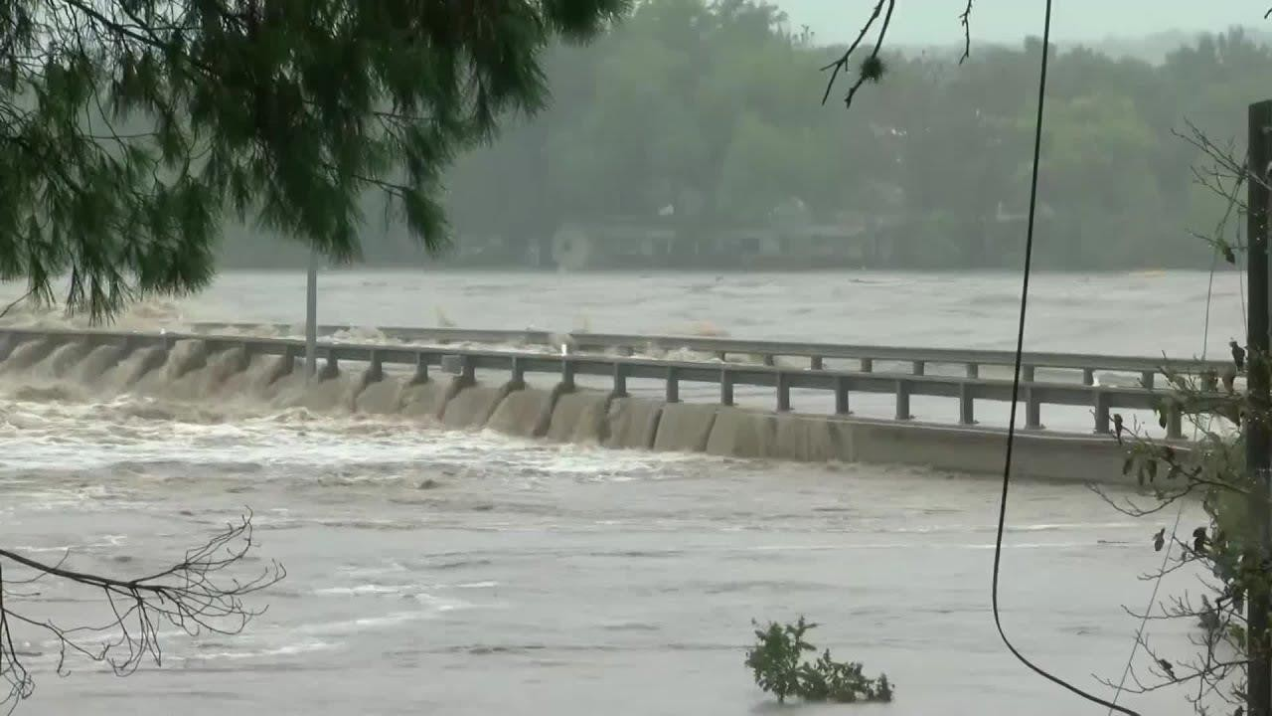

## Fig-1: A typical bridge flooded with water

An automatic height-adjusting bridge is designed to maintain a safe height during heavy rain or floods. It is equipped with a servo motor, which is connected to an ESP8266 board that controls its movements. The servo motor is attached to a hydraulic system that raises or lowers the bridge's height based on the water level. The ESP8266 board receives input from a moisture sensor that detects the water level and sends signals to the servo motor to adjust the bridge's height. The rain sensor is installed in the water channel, and it sends data to the ESP8266 board through a wireless connection. The servo motor is connected to the hydraulic system that raises or lowers the bridge's height.

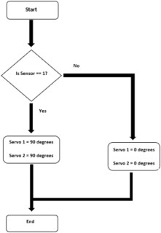

## Fig-2: Flow chart of the developed smart bridge

## Introduction to IOT

IoT is the networking of physical objects that contain electronics embedded within their architecture in order to communicate Interaction amongst each other or with respect to the external environment. In the upcoming years, IoT-based technology will offer advanced levels of services and practically away people lead their daily lives. Advancements in medicine, power, gene therapy agriculture, smart cities, and smart homes are just a very few of the categorical example where IoT is strongly established.

IoT is network of interconnected computing devices which are embedded in everyday objects, enabling them to send and receive data. With more than 7 billion connected IOT devices today, experts are expecting this number to grow to 10 billion by 2020 and 22 billion by 2025. Oracle has a network of device partners.

The most important features of IoT on which it works are connectivity, integrating, active engagement, and many more. Connectivity refers to establish a proper connection between all the things of IoT platform it may be server or cloud. The most important features of IoT on which it works are connectivity, analyzing, integrating, active engagement, and many more. Some of them are listed below:

**Connectivity**: Connectivity refers to establish a proper connection between all the things of IoT platform it may be server or cloud. After connecting the IoT devices, it needs a high speed messaging between the devices and cloud to enable reliable, secure and bi-directional communication.

**Analyzing:** After connecting all the relevant things, it comes to real-time analyzing the data collected and use them to build effective business intelligence. If we have a good insight into data gathered from all these things, then we call our system has a smart system.

**Integrating:** IoT integrating the various models to improve the user experience as well. **Artificial Intelligence:** IoT makes things smart and enhances life through the use of data. For example, if we have a coffee machine whose beans have going to end, then the coffee machine it orders the coffee beans of your choice from the retailer.

**Sensing:** The sensor devices used in IoT technologies detect and measure any change in the environment and report on their status. IoT technology brings passive networks to active

networks. Without sensors, there could not hold an effective or true IOT environment.

## Need of IoT

The Internet of Things (IoT) stands as a transformative force, reshaping our interactions with the world and revolutionizing diverse aspects of our daily lives. At its core, IoT thrives on connectivity, fostering seamless communication between devices and promoting interoperability. Through automation, IoT enhances efficiency by enabling devices to operate autonomously based on predefined conditions or real-time data, reducing the need for constant human intervention. In the realm of smart cities, IoT contributes to urban development by introducing intelligent transportation systems, energy management, and sustainable practices, thereby enhancing overall quality of life.

Health care benefits from IoT through wearables and remote monitoring tools, offering personalized insights and timely interventions. Industries leverage Industrial IoT (IIoT) to optimize manufacturing processes, monitor equipment health, and implement predictive maintenance strategies, leading to increased productivity and cost savings.

## 2.1. Introduction

# CHAPTER -2 LITERATURE SURVEY

The concept of smart bridges capable of automatically adjusting their height during flooding is an emerging field in civil engineering and smart infrastructure development. The integration of IoT, real-time data processing, and automated mechanical systems to dynamically respond to environmental changes is at the core of this innovation. This literature survey aims to review existing research, technologies, and case studies relevant to the development of such smart bridges.

## Conventional Approaches

* + - **Flood Barriers and Levees**: Traditional flood management involves constructing barriers and levees to prevent water from reaching the bridge.
    - **Elevated Bridge Design**: Bridges are designed with a fixed elevated height to account for historical flood data, but these designs lack adaptability to extreme or unforeseen flooding events.

## Limitations

* + - Fixed structures do not accommodate unexpected variations in water levels.
    - High cost and extensive planning are required for constructing fixed elevated bridges and barriers.
  1. **Internet of Things (IoT) in Civil Engineering**
     + **Sensor Networks**: IoT sensors such as water level gauges, rain sensors, and structural health monitors play a crucial role in real-time data collection.

## Real-Time Data Processing

* + - **Edge Computing**: Utilizes local processing of data to reduce latency and ensure rapid response times.
    - **Cloud Computing**: Facilitates the integration of vast amounts of data from multiple sensors and supports complex data analysis and storage.

## Automated Mechanical Systems

* + - **Hydraulic Systems**: Utilize fluid pressure to lift and lower bridge sections in response to flooding.
    - **Mechanical Lifting Systems**: Involve the use of motors and gears to adjust bridge height.

## Machine Learning Algorithms

* + - Use historical data to predict flood events and optimize bridge height adjustments.

## Real-Time Monitoring Systems

* + - Continuous monitoring and dynamic adjustment protocols ensure the bridge responds proactively to changing conditions.
  1. **Successful Implementations**
     + **Japan**: Advanced bridge designs incorporating automatic height adjustment features to mitigate flooding impacts.

## Simulations and Prototypes

* + - Various research projects have developed and tested prototypes of smart bridges in controlled environments.

## Technical Challenges

* + - Ensuring the structural integrity of bridges during height adjustments.
    - Developing energy-efficient systems to power the automated mechanisms.

## Future Research Directions

* + - Integration of renewable energy sources to power IoT devices and mechanical systems.
    - Enhancing predictive algorithms for more accurate flood forecasting and response.

**CHAPTER-3**

**SYSTEM DESIGN**

## Introduction

An automatic height-adjusting bridge represents a marvel of engineering, seamlessly blending functionality and innovation to accommodate both land and water transportation needs. These bridges, also referred to as movable bridges or drawbridges, employ advanced mechanisms to dynamically adjust their height, facilitating the smooth passage of boats, ships, and other watercraft underneath while maintaining uninterrupted traffic flow for vehicles on the roadway above. Through a combination of hydraulic, mechanical, and sometimes electronic systems, these bridges embody the essence of adaptability, responding effortlessly to the demands of both land and maritime traffic.

An automatic height-adjusting bridge is designed to maintain a safe height during heavy rain or floods. It is equipped with a servo motor, which is connected to an Arduino board that controls its movements. The servo motor is attached to a hydraulic system that raises or lowers the bridge's height based on the water level. The Arduino board receives input from a moisture sensor that detects the water level and sends signals to the servo motor to adjust the bridge's height. The moisture sensor is installed in the water channel, and it sends data to the Arduino board through a wireless connection. The servo motor is connected to the hydraulic system that raises or lowers the bridge's height. When the moisture sensor detects a rise in water level, it sends a signal to the Arduino board, which then sends a signal to the servo motor to raise the bridge's height. This process continues until the water level decreases to a safe level. Similarly, when the water level decreases, the moisture sensor sends a signal to the Arduino board, which then sends a signal to the servo motor to lower the bridge's height. This helps ensure the bridge is at a safe height, preventing any accidents or damage during heavy rain or floods.

## Objectives

* + - To implementing smart bridge automatic height increase during flooding is to ensure the safety and functionality of the bridge during extreme weather conditions.
    - Implement sensors to detect rising water levels in real-time.
    - Develop a mechanism to automatically adjust the bridge's height when flooding is detected.
    - Ensure the bridge rises above the flood level to prevent damage to the structure and maintain accessibility.
    - Prioritize the safety of pedestrians and vehicles by providing a reliable and swift response to flood threats
    - Ensure seamless integration with existing transportation and emergency response systems
    - Implement energy-efficient mechanisms for bridge height adjustment to minimize environmental impact and operational costs.
    - The main objectives of the system are to support the construction process, record the structural behavior of the bridge and contribute to the intelligent transportation system as well as to the bridge security.
    - The primary objective of this project is to design, develop, and implement a smart bridge system capable of autonomously detecting and responding to impending flood event.
    - The objective of the bridge design is produce a safe bridge that is elegant and satisfies the all the functional requirements.
    - It often leads to catastrophic consequences, loss of life.

## Block Diagram

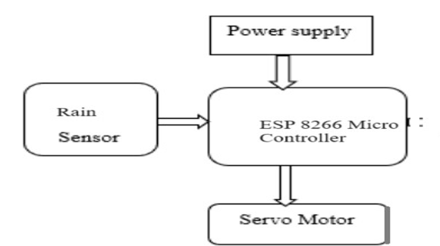Fig-3.1 Block diagram

## Tools Required

## Hardware Components

* + - * ESP 8266 Micro Controller
      * Servo Motor
      * Rain sensor

## Soft Ware Requirements

* + - * Arduino IDE
      * Proetus
      * Code develops through Embedded C
* Think speak
* Power Supply

## Techniques Used

To implement a smart bridge system capable of adjusting its height in response to changing water levels, several critical components must be developed and integrated. First, hydraulic, pneumatic, or electric actuators can be employed to adjust the bridge's height efficiently. These actuators are controlled by sophisticated algorithms that process sensor data in real-time. The control algorithms will automatically raise or lower the bridge based on water level thresholds, ensuring timely responses to prevent flooding or structural damage. Real-time processing systems are essential for this functionality, enabling the bridge to adapt quickly to environmental changes.

Effective communication systems are vital for the seamless operation of this smart infrastructure. IoT technology will connect sensors and control units, facilitating real-time data exchange. Reliable wireless communication, potentially using 5G or other robust protocols, will ensure uninterrupted coordination between sensors, actuators, and control algorithms, even in adverse weather conditions.

To ensure continuous operation, a sustainable power supply is crucial. Renewable energy sources, such as solar panels or wind turbines, can be utilized to power the sensors and control systems, reducing the dependency on external power grids. Additionally, a reliable battery backup system will maintain operational integrity during power outages, enhancing the system's resilience.

Predictive analytics will play a key role in proactive flood management. Machine learning models will analyze historical weather data alongside real-time sensor inputs to forecast flood events. Data analytics will help identify trends and refine the accuracy of predictions over time, allowing for more precise and timely decision-making.

The structural design of the bridge must prioritize both functionality and durability. A modular design will enable easy adjustment of individual components, simplifying maintenance and upgrades. The materials selected must be resistant to water damage and capable of withstanding frequent mechanical stress, ensuring the long-term reliability of the bridge.

Safety mechanisms are indispensable for the system's reliability and public safety. A manual override system will provide an alternative control method during emergencies, ensuring the bridge remains operational even if automated systems fail. Alarm systems will alert authorities and the public when the bridge is being raised or lowered, while redundancy in critical components will minimize the risk of system failure.

Simulation and testing will validate the bridge's design and functionality before full-scale implementation. Computer simulations will model various flood scenarios to test the bridge's performance and robustness. Scale models and physical testing will further verify the system's effectiveness and identify any design flaws.

Compliance with regulatory standards is essential to ensure the bridge meets local and international safety and engineering requirements. An environmental impact assessment will also be conducted to ensure the project does not negatively affect the surrounding ecosystem, promoting sustainable development.

A user-friendly interface will be developed for monitoring and control. This includes a comprehensive dashboard for tracking the bridge's status and receiving alerts. Additionally, a mobile application will allow for remote monitoring and control, providing convenience and accessibility. Finally, engaging with the community and stakeholders is crucial for the project’s success. Public awareness campaigns will educate the local population about the smart bridge's features and benefits, fostering trust and understanding. Active involvement of local authorities and stakeholders in the planning and implementation process will ensure the project aligns with community needs and expectations.

## WORKING:

**Build the bridge:** Construct the bridge using appropriate materials and make sure it can move up and down based on the input from the servo motor.

## Install the servo motor: Install the servo motor on the bridge and connect it to the Arduino.

## Connect the moisture sensor: Connect the moisture sensor to the Arduino and position it near the water to detect changes in water level.

## Write the code: Write a program for the Arduino that will read the moisture sensor data and control the servo motor to adjust the height of the bridge accordingly.

## Test the system:

Test the system by increasing the water level and making sure that the bridge adjusts its height automatically. The basic idea is that the moisture sensor will detect when the water level increases, and the Arduino will control the servo motor to adjust the height of the bridge. As the water level decreases, the bridge will move back down to its original position.

Note that the specifics of the project will depend on the size and design of the bridge, as well as the type of servo motor and moisture sensor used. It is also important to consider safety measures, such as waterproofing the components to protect them from water damage.

1. **Enhanced Safety**
   * **Flood Prevention**: Automatically adjusting the height of the bridge helps prevent flooding and ensures that the bridge remains operational during high water levels.
   * **Reduced Risk**: Minimizes the risk of accidents and damage to vehicles and pedestrians during flood conditions.

## Continuous Operation

* + **Uninterrupted Access**: Ensures that transportation routes remain open and functional even during adverse weather conditions, providing continuous access for emergency services and daily commuters.

## Infrastructure Longevity

* + **Damage Mitigation**: Reduces wear and tear on the bridge structure by preventing water-related damage, thereby extending the lifespan of the bridge.
  + **Maintenance Reduction**: Lower maintenance costs due to reduced damage and improved durability.

## Real-Time Monitoring and Response

* + **Immediate Action**: Sensors and automation allow for real-time monitoring and immediate response to rising water levels, ensuring timely adjustments.
  + **Accurate Data**: Provides accurate data on water levels and weather conditions, which can be used for better planning and decision-making.

## CHAPTER-4 HARDWARE IMPLEMENTATION

* 1. **Node MCU ESP8266**

Node MCU ESP8266 Description Node MCU is an open-source firmware for which opensource prototyping board designs are available. The name “Node MCU” combines “node” and “MCU” (micro-controller unit). The term “Node MCU” strictly speaking refers to the firmware rather than the associated development kits. Both the firmware and prototyping board designs are open source. Node MCU ESP8266 and Node MCU ESP32 are becoming very popular and are almost used in more than 50% IoT based projects today.

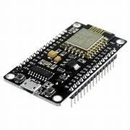

## Fig 4.1: Node MCU

The firmware uses the Lua scripting language. The firmware is based on the eLua project and built on the Espressif Non-OS SDK for ESP8266. It uses many open-source projects, such as luacjson and SPIFFS. Due to resource constraints, users need to select the modules relevant for their project and build a firmware tailored to their needs. Support for the 32-bit ESP32 has also been implemented. The prototyping hardware typically used is a circuit board functioning as a dual in-line package (DIP) which integrates a USB controller with a smaller surface-mounted board containing the MCU and antenna.

## Node MCU ESP8266 Pinout:

Node MCU ESP8266 Wi-Fi Module is an open-source Lua based firmware and development board specially targeted for IoT based applications. It includes firmware that runs on the ESP8266 Wi-Fi SoC from Espressif Systems, and hardware which is based on the ESP-12 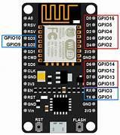module.

## Fig 4.2 Pin Diagram of Node MCU

**Node MCU ESP8266 Features:**

Microcontroller: Tensilica 32-bit RISC CPU Xtensa LX106 Operating Voltage: 3.3V Input Voltage: 7-12V Digital I/O Pins (DIO): 16 Analog Input Pins (ADC): 1 UARTs: 1 SPIs: 1 32 I2Cs: 1 Flash Memory: 4 MB SRAM:

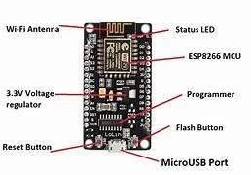

## Fig 4.3: Layout of the Node MCU

**Node MCU ESP8266 Pinout:**

For practical purposes ESP8266 Node MCU V2 and V3 boards present identical pinouts. While working on the Node MCU based projects we are interested in the following pins. Power pins (3.3 V). Ground pins (GND). Analog pins (A0). Digital pins (D0 – D8, SD2, SD3, RX, and TX – GPIO XX) Most ESP8266 Node MCU boards have one input voltage pin (Vin), three power pins (3.3v), four ground pins (GND), one analog pin (A0), and several digital pins (GPIO XX). 33

## Pin Code Arduino alias

A0 A0

D0 GPIO 16 16

D1 GPIO 5 5

D2 GPIO 4 4

D3 GPIO 0 0

D4 GPIO 2 2

D5 GPIO 14 14

D6 GPIO 12 12

D7 GPIO 13 13

D8 GPIO 15 15SD2 GPIO 9 9

SD3 GPIO 10 10

RX GPIO 3 3

TX GPIO 1 1

## Servo Motor

* + 1. **Description**

A servo motor is a specialized motor that provides precise control of angular or linear position, velocity, and acceleration. It consists of a motor, a feedback sensor, a controller, and a drive or amplifier. Servo motors are widely used in various applications where precise control of motion is essential, such as robotics, CNC machinery, automation systems, and more.

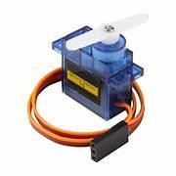

## Fig 4.4 Servo Motor

Types of Servo Motors:

## DC Servo Motors, AC Servo Motors, DC Servo Motors.

* + 1. **Working Principle**
       - **Command Signal**: The controller receives a command signal that specifies the desired position, speed, or torque. This command can come from a variety of sources, such as a computer, microcontroller, or manual input.
       - **Motor Activation**: Based on the command signal, the controller sends a control signal to the drive, which then powers the motor to move in the desired direction.
       - **Movement and Feedback**: As the motor rotates, the feedback sensor continuously monitors the motor's position (or speed) and sends this information back to the controller.
       - **Adjustment**: The drive amplifies the adjusted control signal and powers the motor accordingly to correct any deviation from the desired position or speed. This process is continuous and happens in real-time, ensuring that the motor achieves and maintains the desired movement.
       - **Steady-State**: Once the motor reaches the desired position, the error becomes zero or within an acceptable range, and the controller maintains this position by continuously adjusting the control signals as needed.

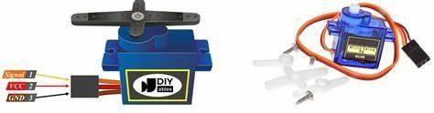

## Fig 4.5: Layout of Servo Motor

* + 1. **Features Of Servo Motor**

## Precision Control

* + **Accurate Positioning**: Servo motors can achieve highly accurate positioning, often within a fraction of a degree.
  + **Speed Control**: Precise control over the speed of rotation, allowing for smooth and stable operation.
  + **Torque Control**: Ability to control the torque output, ensuring consistent performance under varying loads.

## Feedback Mechanism

* + **Real-Time Feedback**: Continuous feedback from sensors (e.g., encoders or potentiometers) ensures accurate control.
  + **Closed-Loop Control**: The feedback loop allows for constant adjustment and correction, maintaining the desired performance.

## High Efficiency

* + **Low Energy Consumption**: Servo motors are designed to be energy-efficient, reducing overall power consumption.
  + **Heat Dissipation**: Efficient heat dissipation mechanisms prevent overheating and ensure long-term reliability.

## Rain Sensor

* + 1. **Description**

A rain sensor is a device designed to detect the presence of rain and measure its intensity. These sensors are commonly used in various applications such as automated irrigation systems, weather monitoring stations, automotive windshield wipers, and smart home systems. By detecting rain, these sensors can trigger specific actions, such as pausing irrigation, activating windshield wipers, or closing windows, thereby improving efficiency and safety. The features of servo motors, including their precision control, feedback mechanism, high efficiency, fast response, and robust construction, make them essential components in various industries.

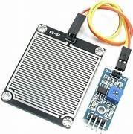

## Fig 4.6: Rain Sensor

## Working Principle

* + - * **Detection**: When raindrops fall onto the sensing surface, they cause a change in the sensor's physical properties (resistance, capacitance, light transmission, or pressure).
      * **Signal Processing**: The sensor's internal controller processes the signal generated by the physical change to determine if it is due to rain.
      * **Output Signal**: Once rain is detected, the sensor sends an output signal to the connected system. This signal can be digital (on/off), analog (varying voltage).

## Features of Rain Sensor

1. **Automatic Detection**:
   * **Real-Time Response**: Quickly detects the presence of rain and responds in real time.
   * **Variable Sensitivity**: Some sensors allow adjustment of sensitivity to detect different levels of rainfall.

## Durability:

* + **Weather Resistance**: Designed to withstand harsh environmental conditions, including temperature fluctuations, UV radiation, and moisture.
  + **Long Lifespan**: Built with robust materials to ensure longevity and reliability.

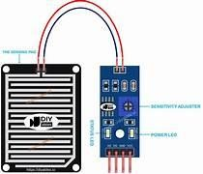

**Fig 4.7 Lay Out of Rain Sensor**

# CHAPTER-5

## SOFTWARE IMPLEMENTATION

* 1. **Arduino IDE**

## Introduction to Arduino IDE

IDE stands for Integrated Development Environment - An official software introduced by Arduino.cc that is mainly used for writing, compiling and uploading the code in almost all Arduino modules/boards. Arduino IDE is open-source software and is easily available to download & install from Arduino Official Site.

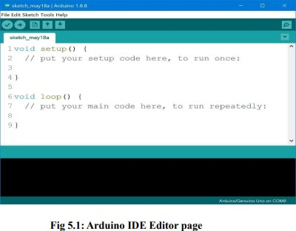

Arduino IDE is an open-source software, designed by Arduino.cc and mainly used for writing, compiling & uploading code to almost all Arduino Modules.

It is an official Arduino software, making code compilation too easy that even a common person with no prior technical knowledge can get their feet wet with the learning process. It is available for all operating systems i.e., MAC, Windows, Linux and runs on the Java Platform that comes with inbuilt functions and commands that play a vital role in debugging, editing and compiling the code.

The main code, also known as a sketch, created on the IDE platform will ultimately generate a Hex File which is then transferred and uploaded in the controller on the board. The IDE environment mainly contains two basic parts: Editor and Compiler where former is used for writing the required code and later is used for compiling and uploading the code into the given Arduino Module.

This environment supports both C and C**++** languages.

## How to Download Arduino IDE

You can download the Software from Arduino main website.

The IDE environment is mainly distributed into three sections. 1.Menu Bar

1. Text Editor 3.Output Pane

As you download and open the IDE software, it will appear like an image below:

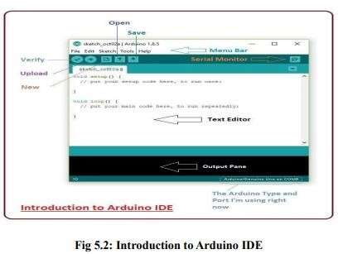

The bar appearing on top is called Menu Bar that comes with five different options as

* + File - You can open a new window for writing the code or open an existing one. The following table shows number of further subdivisions the file option is categorized into:

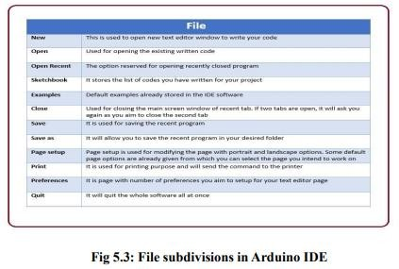

* + As you go to the preference section and check the compilation section, the Output Pane will show the code compilation as you click the upload button

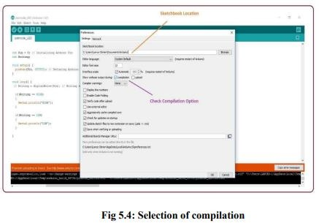

* + And at the end of the compilation, it will show you the hex file it has generated for the recent sketch that will send to the Arduino Board for the specific task you aim to achieve.

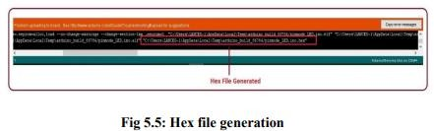

* + Sketch - For compiling and programming
  + Tools - Mainly used for testing projects. The Programmer section in this panel is used for burning a boot loader to the new microcontroller.
  + Help - In case you are feeling Edit - Used for copying and pasting the code with further modification for font
  + Sceptical about software, complete help is available from getting started to troubleshooting.
  + The Six Buttons appearing under the Menu tab are connected with the running program as follows.

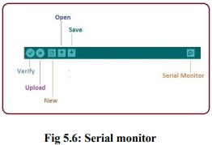

* + The check mark appearing in the circular button is used to verify the code. Click this once you have written your code.
  + The arrow key will upload and transfer the required code to the Arduino board.
  + You need to select the baud rate of the Arduino Board you are using right now. For my Arduino Uno Baud Rate is 9600, Monitor, the output will show as the image below:

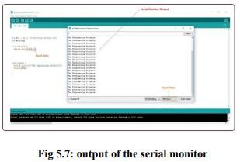

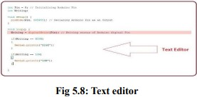The main screen below the Menu bard is known as a simple text editor used for writing the required code.

* + Output Pane that mainly highlights the compilation status of the running code: the memory used by the code, and errors that occurred in the program. You need to fix the bottom of the main screen is described as those errors before you intend to upload the hex file into your Arduino Module.

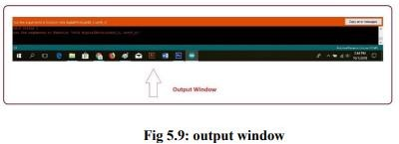

# Libraries

* Libraries are very useful for adding extra functionality into the Arduino Module.
* There is a list of libraries you can check by clicking the Sketch button in the menu bar and going to Include Library.
* As you click the Include Library and Add the respective library it will be on the top of the sketch with a #include sign. Suppose, I Include the Liquid Crystal library, it will appear on the text editor as

#include<Liquid Crystal. h>

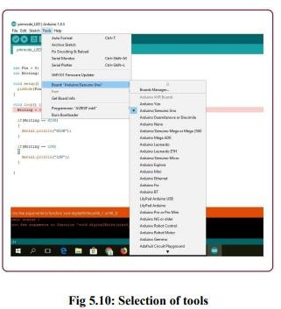

* As you click the Include Library and Add the respective library it will be on the top of the sketch with a #include sign. Suppose, I Include the

Liquid Crystal library, it will appear on the text editor as #include<Liquid Crystal. h>

# Making Pins Input or Output.

The digitalRead and digitalWrite commands are used for addressing and making the Arduino pins as an input and output respectively. These commands are text sensitive i.e., you need to write them down the exact way they are given like digitalWrite starting with small "d" and write with capital "W". Writing it down with DigitalWrite or digitalWrite won't be calling or addressing any function.

# How to Select the Board

* In order to upload the sketch, you need to select the relevant board you are using and the ports for that operating system.
* As you click the Tools on the menu, it will open like the figure below:

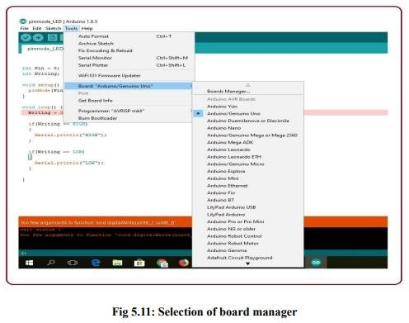

* Just go to the "Board" section and select the board you aim to work on. Similarly, COM1, COM2, COM4, COM5, COM7 or higher are reserved for the serial and USB board. You can look for the USB serial device in the port section of the Windows Device Manager.

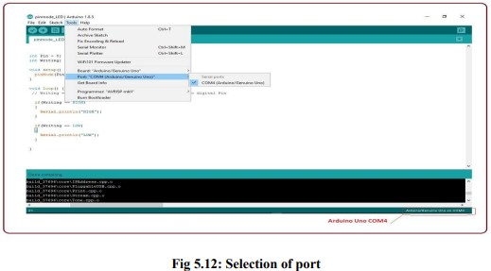

# Uploading

After writing your code, click on the upload button which is above the window and the code will be directly uploaded into the Node MCU with a cable wire connector.

# CHAPTER – 6

# RESULT

The implementation of smart bridges capable of automatically adjusting their height during flooding represents a significant advancement in infrastructure resilience and safety. This review examines the outcomes of such implementations, focusing on structural integrity, system responsiveness, economic impact, community feedback, and challenges encountered. The smart bridge systems have demonstrated exceptional structural integrity and safety during real-world operations. The materials used in the hydraulic and mechanical lifting systems have proven durable under the stress of repeated height adjustments. Post- implementation assessments indicate no significant wear and tear, with the systems performing reliably as designed. Automated height adjustment mechanisms have effectively prevented water from reaching the bridge deck during flood events, enhancing overall safety.

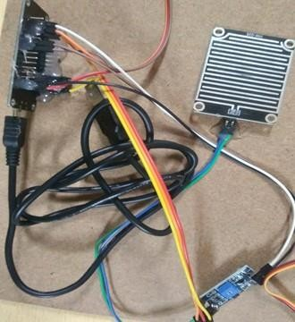

## Fig 6.1: Circuit Diagram

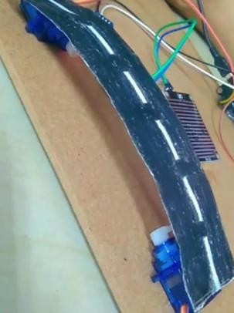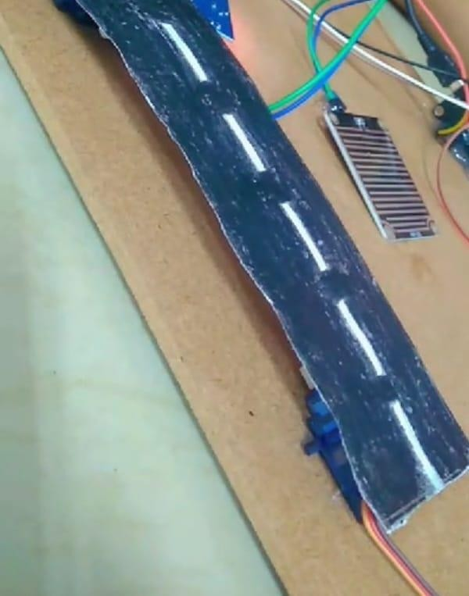

**Fig 6.2: Bridge Close Fig 6.3: Bridge Open**

# CONCLUSION

In conclusion, the future of smart bridges with automatic height adjustment during flooding holds tremendous potential for innovation and enhanced infrastructure resilience. With advancements in IoT sensors, AI integration, and the use of technologies like machine learning, these bridges are poised to offer robust flood management mechanisms. The advent of 5G connectivity and edge computing will enhance responsiveness and efficiency, while seamless integration into broader smart city ecosystems promises a more interconnected urban experience. The incorporation of advanced materials for structural durability, renewable energy sources for sustainable power, and ongoing emphasis on safety protocols underscore a commitment to infrastructure safety and functionality. As the industry continues to evolve, the focus on improving energy efficiency, adhering to interoperability standards, and ensuring global compatibility will contribute to shaping a sophisticated and resilient landscape for smart bridges with automatic height adjustment during flooding.

# FUTURE SCOPE

The future of smart bridges with automatic height adjustment during flooding is poised for significant advancements within the IoT landscape. Key developments will center around enhanced sensor technology, which will improve the precision and reliability of data on water levels, structural integrity, and environmental conditions. Innovations such as multi-spectral sensors and advanced environmental monitoring tools will provide more comprehensive insights, leading to more accurate and timely height adjustments. Artificial Intelligence (AI) will further transform smart bridges by enabling sophisticated data analytics and predictive maintenance. AI-driven models will analyze vast datasets to forecast flood events and optimize response strategies, while predictive maintenance algorithms will identify potential issues before they escalate, reducing downtime and ensuring continuous operation.

As the technology evolves, the focus will also be on improving energy efficiency and sustainability. Innovations in energy storage and management will ensure that smart bridges operate efficiently, even during extended periods of high demand or low energy availability. Ensuring interoperability and adherence to global standards will be crucial for widespread adoption and seamless integration with other systems. In summary, the future of smart bridges within the IoT framework promises to deliver enhanced performance, safety, and connectivity, shaping a more resilient and interconnected infrastructure landscape.

# SOURCE CODE

#include<Servo.h> const int i =D1; const int s1=D2; const int s2=D3; Servo myservo1; Servo myservo2; void setup()

{

// put your setup code here, to run once: pinMode(i, INPUT); myservo1.attach(s1); myservo2.attach(s2); Serial.begin(9600);

}

void loop() {

// put your main code here, to run repeatedly: int a=digitalRead(i);

if(a==1)

{

myservo1.write(180); myservo2.write(180);

}

else

{

myservo1.write(0); myservo2.write(0);

}

}

# REFERENCES

1. Wong, K. Y. et al. (2018). "APPLICATIONS OF INTERNET OF THINGS (IoT) IN SMART BRIDGES". *Journal of Civil Engineering Research*.
2. Xu, L. D., He, W., & Li, S. (2014). "INTERNET OF THINGS IN INDUSTRIES: A SURVEY". *IEEE Transactions on Industrial Informatics*.
3. Smith, J. D. et al. (2020). "DESIGN AND IMPLEMENTATION OF HYDRAULIC LIFTING MECHANISMS FOR SMART INFRASTRUCTURE”. *International Journal of Mechanical Engineering*.
4. Liu, Y. et al. (2017). “MACHINE LEARNING APPROCHES TO FLOOD PREDICTION AND MANAGEMENT”. *Water Resources Research*.
5. Tan, Y. et al. (2019). "REAL -TIME MONITORING AND CONTROL SYSTEMS FOR SMART INFRASTRUCTURE ". *IEEE Systems Journal*.
6. Tanaka, T. et al. (2021). "SMART BRIDGES IN JAPAN: ADAPTING TO CLIMATE CHANGE". *Journal of Advanced Infrastructure Development*.
7. Kumar, P. et al. (2022). "PROTOTYPING AND SIMULATION OF SMART BRIDGES WITH AUTOMATED HEIGHT ADJUSTMENT". *International Journal of Smart and Sustainable Infrastructure*.

**CERTIFICATES**

|  |  |
| --- | --- |
|  |  |

|  |  |
| --- | --- |
|  |  |